|  |  |
| --- | --- |
| Logo_FPT_University_doc | **MINISTRY OF EDUCATION AND TRAINING** |

**FPT UNIVERSITY**

**CAPSTONE PROJECT DOCUMENT**

**AGC101**

**Report #6 – User's Manual Documents**

|  |  |
| --- | --- |
| **Tra Da** | |
| **Group Member** | SE03451 – Soulivong Phimmathong |
| SE03271 – Hoang Van Canh |
| SE03030 – Vu Hoang Hieu |
| SE03193 – Nguyen Hoang |
| **Supervisor** | Mr. Nguyen Van Sang |
| **Project Code** | AGC101 |

Hanoi, May 2016 – August 2016

Table of Contents

[1 INSTALLATION GUIDE 3](#_Toc459655415)

[1.1 Purposes 3](#_Toc459655416)

[1.2 Environments 3](#_Toc459655417)

[1.3 Application Installation 3](#_Toc459655418)

[1.3.1 Upload application to host 3](#_Toc459655419)

[1.3.2 Installing database 7](#_Toc459655420)

[1.3.3 Manage Admin account 10](#_Toc459655421)

[2 USER's GUIDE 11](#_Toc459655422)

[2.1 Purposes 11](#_Toc459655423)

[2.2 Functional Description 12](#_Toc459655424)

[2.3 Detailed Guidelines 12](#_Toc459655425)

[2.3.1 Guide line for Admin management 12](#_Toc459655426)

[2.3.2 Guide line for Customer 22](#_Toc459655427)

[2.3.3 Guide line for restaurant management 29](#_Toc459655428)

[2.3.4 Guide line for Guest 36](#_Toc459655429)

[3 PROJECT RESULT REPORT 43](#_Toc459655430)

[3.1 Product Judging 43](#_Toc459655431)

[3.1.1 Advantages of AGC web application 43](#_Toc459655432)

[3.1.2 Current limitations of AGC web application 44](#_Toc459655433)

[3.1.3 Expectation in the future 44](#_Toc459655434)

[3.2 Project Summary 45](#_Toc459655435)

[3.3 Lessons Learnt 46](#_Toc459655436)

[3.3.1 Project management skill 46](#_Toc459655437)

[3.3.2 Soft skill 46](#_Toc459655438)

[3.3.3 Technical skill 46](#_Toc459655439)

# INSTALLATION GUIDE

## Purposes

This part contains guidelines for admin to deploy and manage site on web host.

## Environments

- Operating System: Windows XP or higher

- Application server: AGC application system requires an application server running on Linux

- Browsers: Firefox 48, Chrome 50 or higher.

- Database: MySQL 5.6 or higher

- PHP 5.6 or higher

## Application Installation

### Upload application to host

Note: We assume that you already have a host sever with a domain name.

* After login to your host account you can see host manage page as bellow (different host may has different UI but main Item that will be used in this guide is the same)

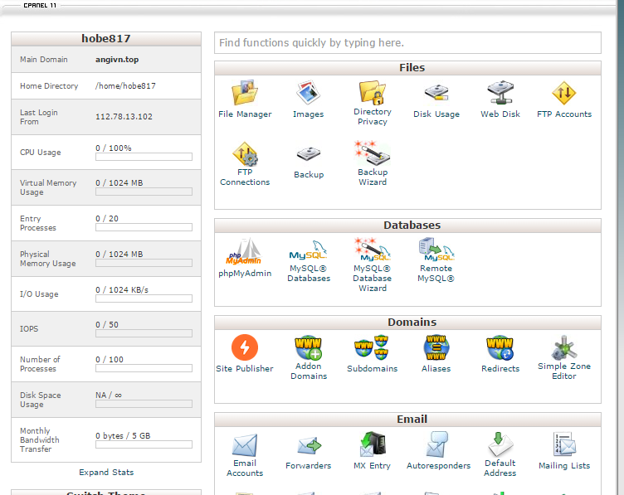

Figure 1: Host management page

* From here, click on ‘File manager’ in Files group

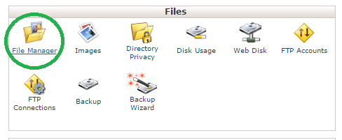

Figure 2: File Manager

* Then go to ‘public\_html’ folder

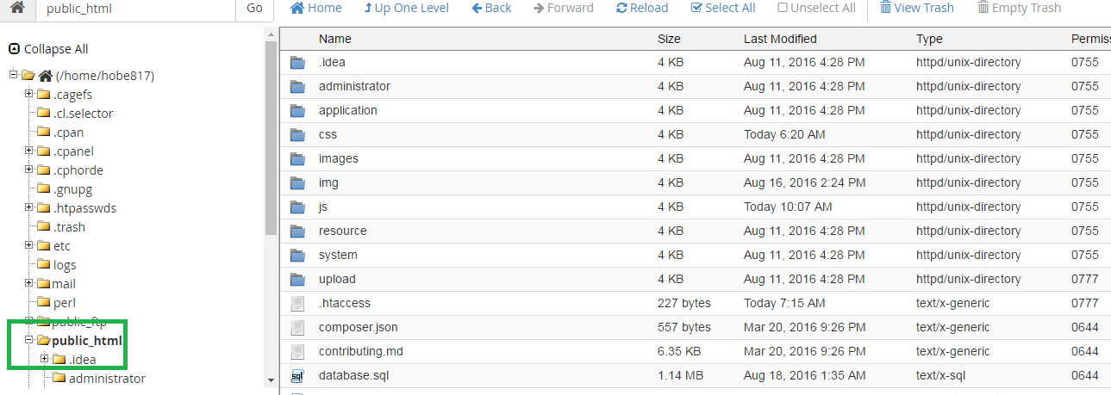

Figure 3: ‘public\_html’ folder

* After that, go to AGC project folder and compressed this folder to .zip format (can be done by using some compressed software like Winrar, 7zip …)

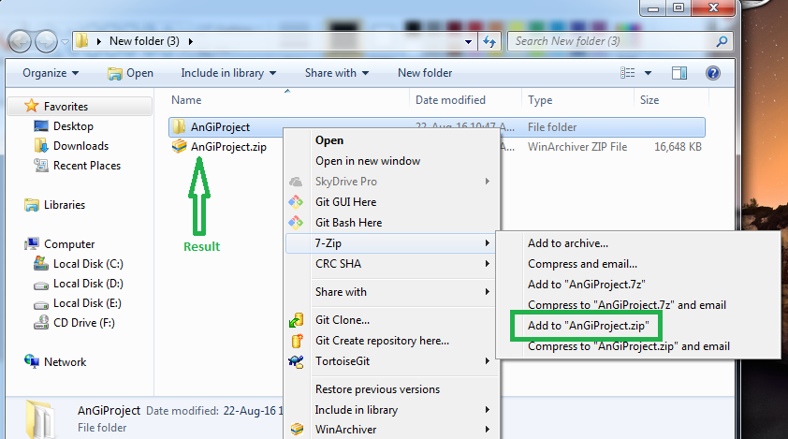

Figure 4: Compressed project

* Then comeback to ‘public\_html’ in browser and click on ‘upload’ in menu bar to upload .zip project.

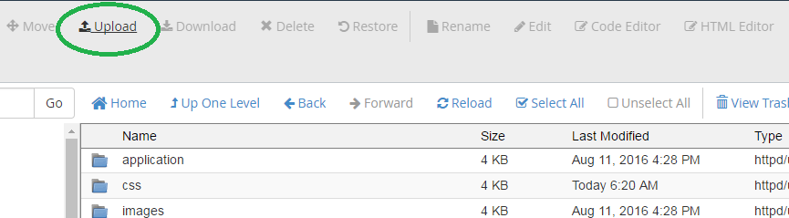

Figure 5: Upload in menu

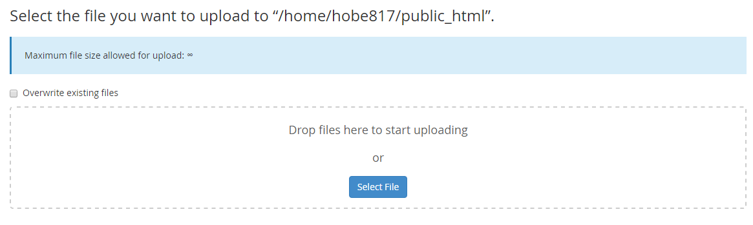

Figure 6: Upload form

* After upload, go ‘pubcic\_html’ click on file that you uploaded and extract it

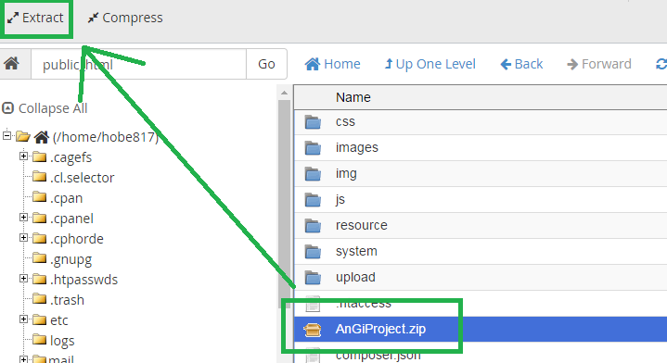

Figure 7: Extract project

### Configure database script file and project

* You can modify database file and change project to adapt with new database
* You can find Database script file in our project at “…\AngiProject\ database.sql” then try to open it with Notepad++.

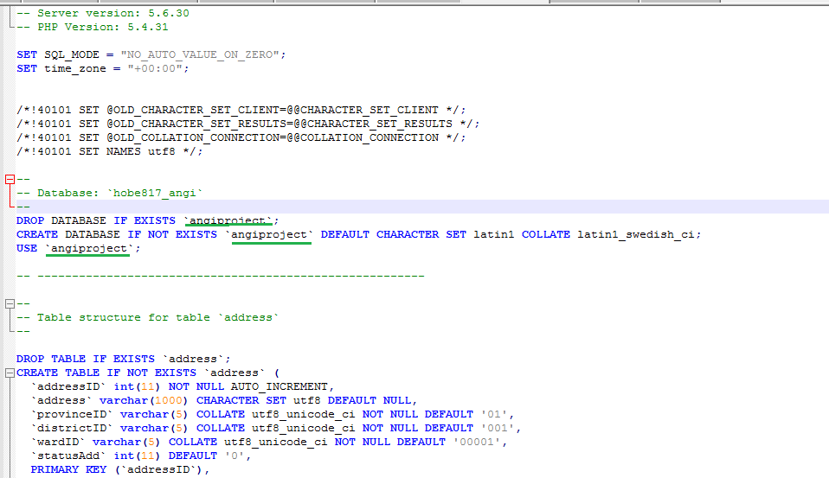

Figure 8: Database script

* From there, you can change database name (here is ‘angiproject’), the script bellow is the script define structure of database, you can modify for future update application.
* After that, you have to configure database connection at ‘…\AngiProject\application\config\database.php’. After open it by Notepad++ you can configure to match with your database and your host

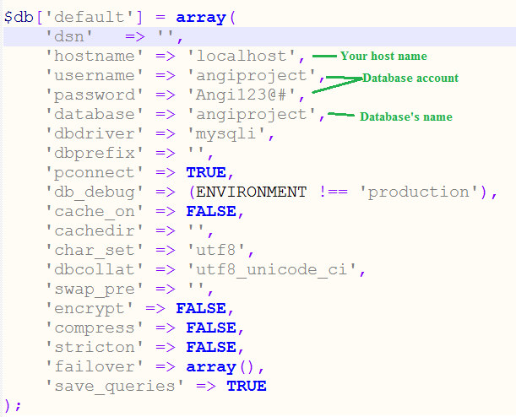

Figure 9: Database.php file

* Then open config.php file at ‘..AngiProject\application\config.php’ and configure base Url to your website domain

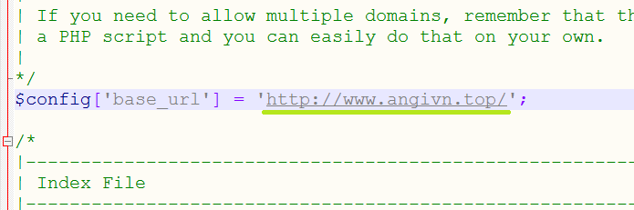

Figure 10: Base url

* After that,open file ‘…\AngiProject\resource\ckeditor\config.js’ to change link to your website domain

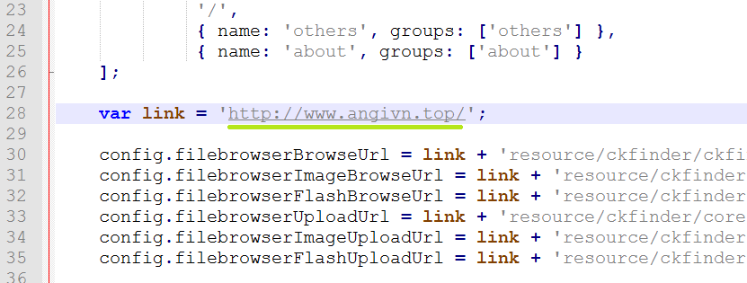

Figure 11: Ckeditor file

### Installing database

* In host manager page, find and click on ‘phpMyAdmin’ in Databases group

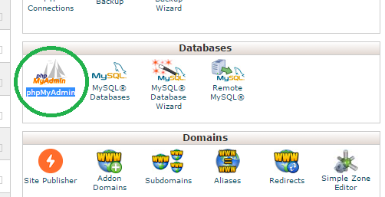

Figure 12: phpMyAdmin icon

* After that, a new phpMyAdmin page will be displayed in your browser. From there click on SQL tab (1) then copy Database script content that we provide (can be found in project folder: \AngiProject\ database.sql) to input form (2) and click Go to create database (3).

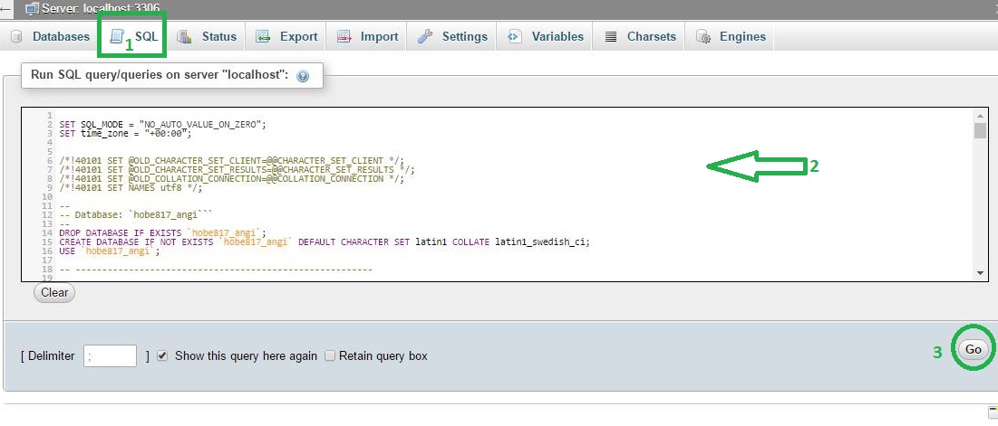

Figure 13: Create database

* After this step, you can use Application normally by access to your domain.

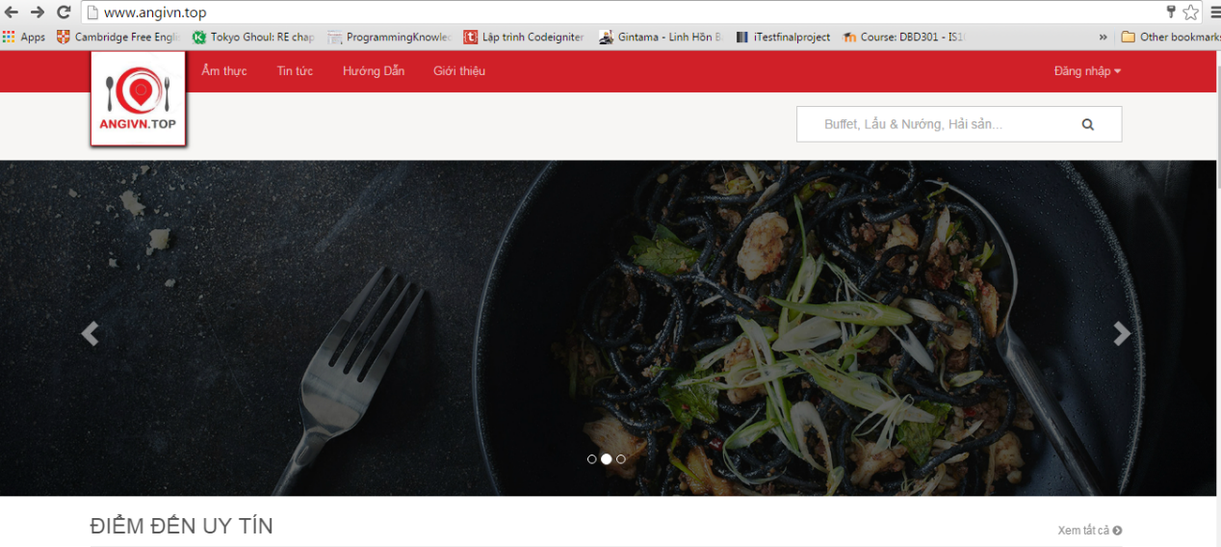

Figure 14: Web application

### Manage Admin account

* After install application, the default admin account is:

User name: admin

Password: 123456

* You can login to admin and go to profile page (login guide can be found below in user guide)
* After that go to admin profile by ‘Thông tin cá nhân’ link

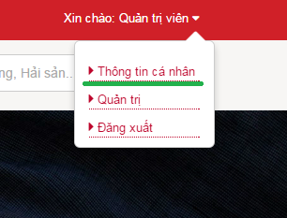

Figure 15: Profile link

* In admin’s profile page go to tab ‘Đổi mật khẩu’ to change password:

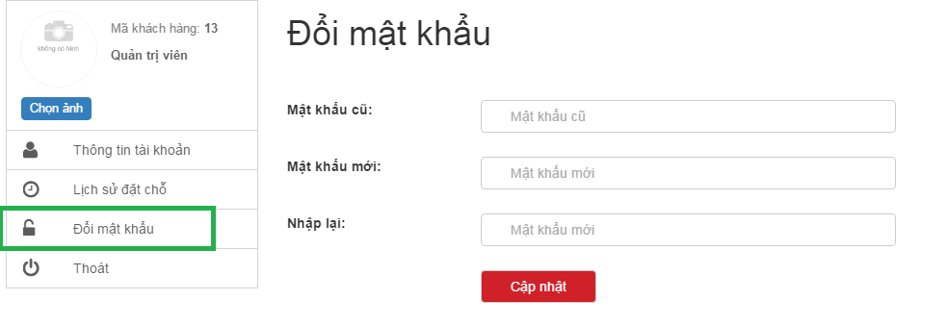

Figure 16: Change password form

* From there change password to make admin account become private for use in the future.

# USER's GUIDE

## Purposes

This document is created to instruct users of how to use main function in AGC system in computers, especially for restaurant owner to manage his/her content.

## Functional Description

Users need only a device that has intenet connection and a web browser to access and perform general function in AGC system. Meanwhile, AGC also reserves functions for specific types of users, means that they can access and manage theirs own privilege functionalilies while others cannot. The only requirement is users need to register on AGC system and are approved by admin (Admin account is manually created by Tra Da developing team).

## Detailed Guidelines

### Guide line for Admin management

#### How to access admin page

* 1. Login as admin (similar with Login – customer guide)
  2. Hover mouse over “Xin chào Quản trị viên” text on the top right of the navigation bar, then click on “Quản trị” link

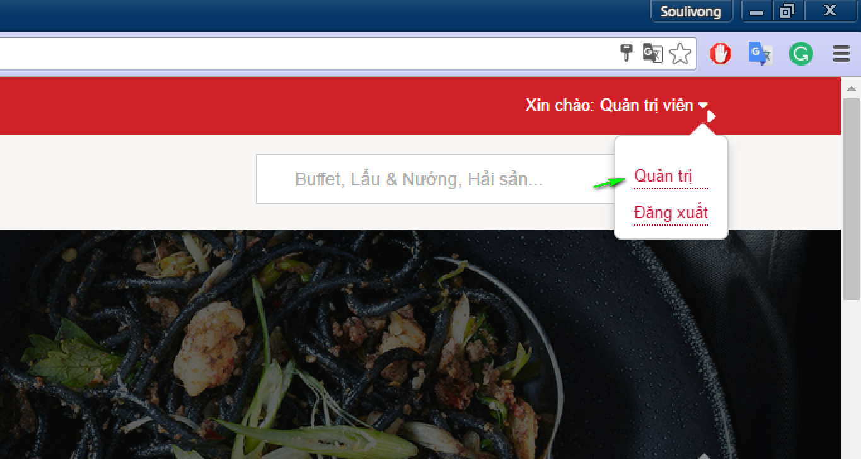

Figure 17: Profile link

#### Step by step to write a new

* + Access admin page then click on “Tin tức”, then “Thêm mới” and enter data as needed and click “Cập nhật” button

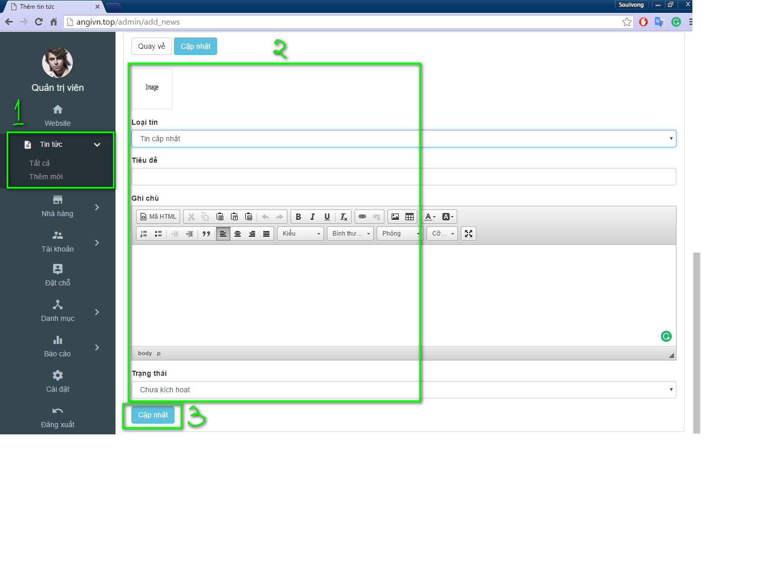

Figure 18: Add new

#### Way to update or edit your news

* 1. Access admin page, then click on “Tin tức”, then “Tất cả”, and click on “Xem” button

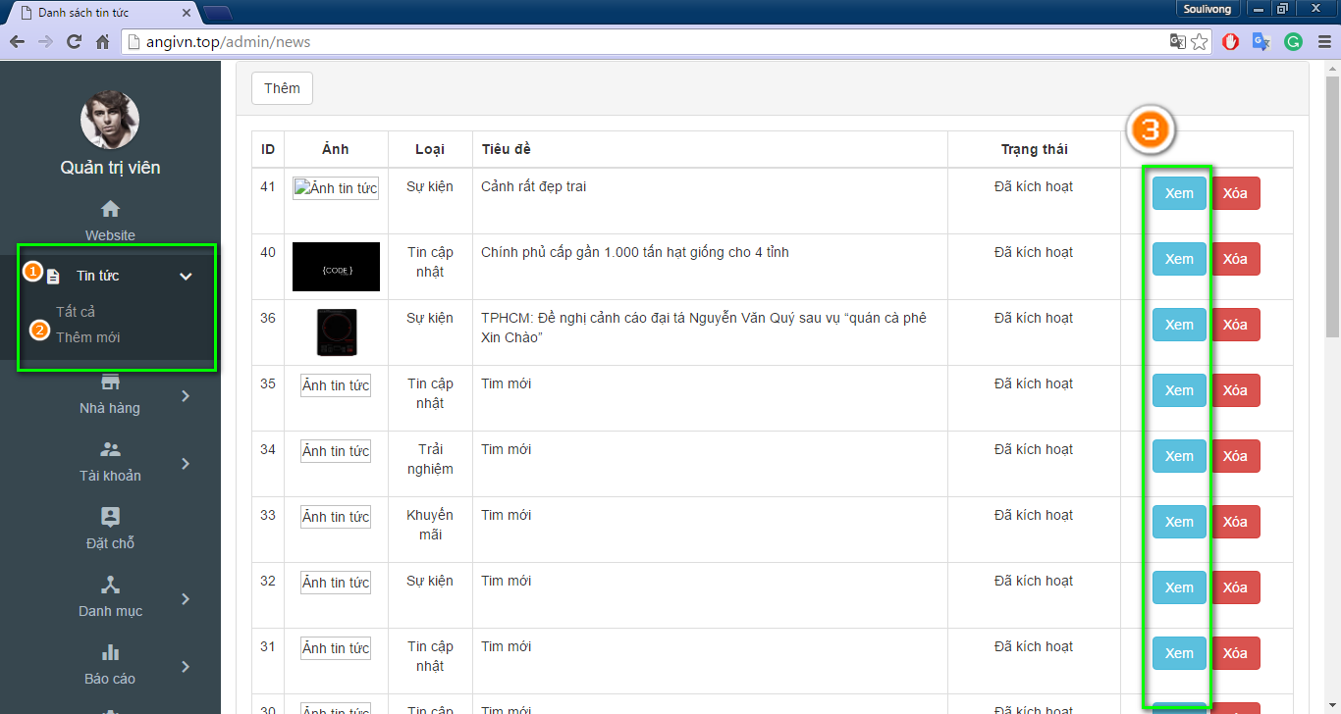

Figure 19: Admin view new

* 1. Modify information as needed and click on “Cập nhật” button. You can also show/hide news by change status to active/ deactive.

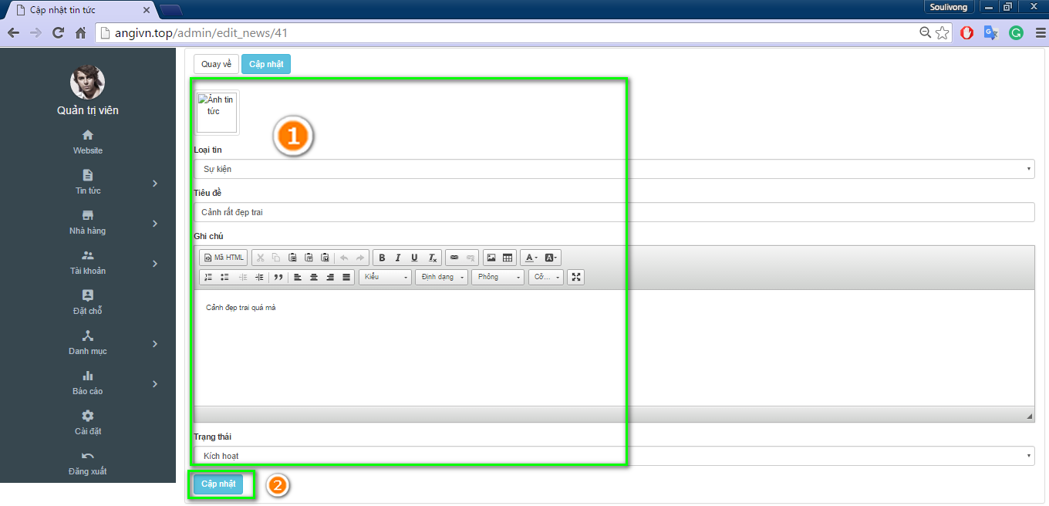

Figure 20: Edit new

#### Plan to add category to website

* + Access admin page, click on “Danh mực” tab, “Thêm mới” tab, then insert information as needed and click “Lưu” button

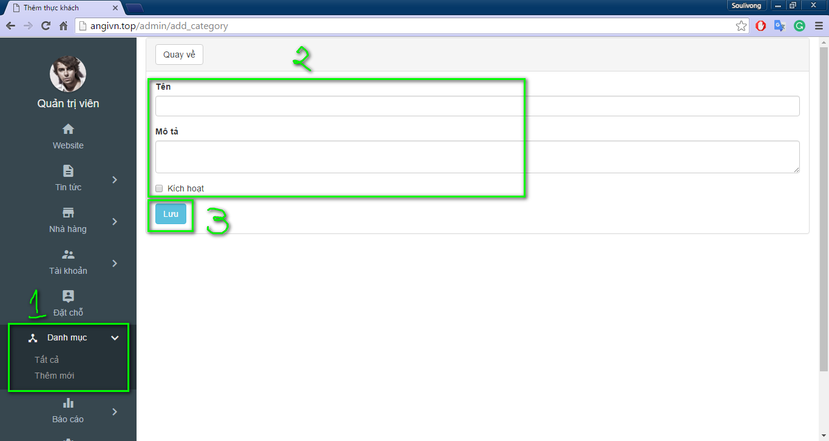

Figure 21: Add category

#### Update category

* 1. Access admin page, click on “Danh mực” tab, “Tất cả” tab, and then “Sửa” button

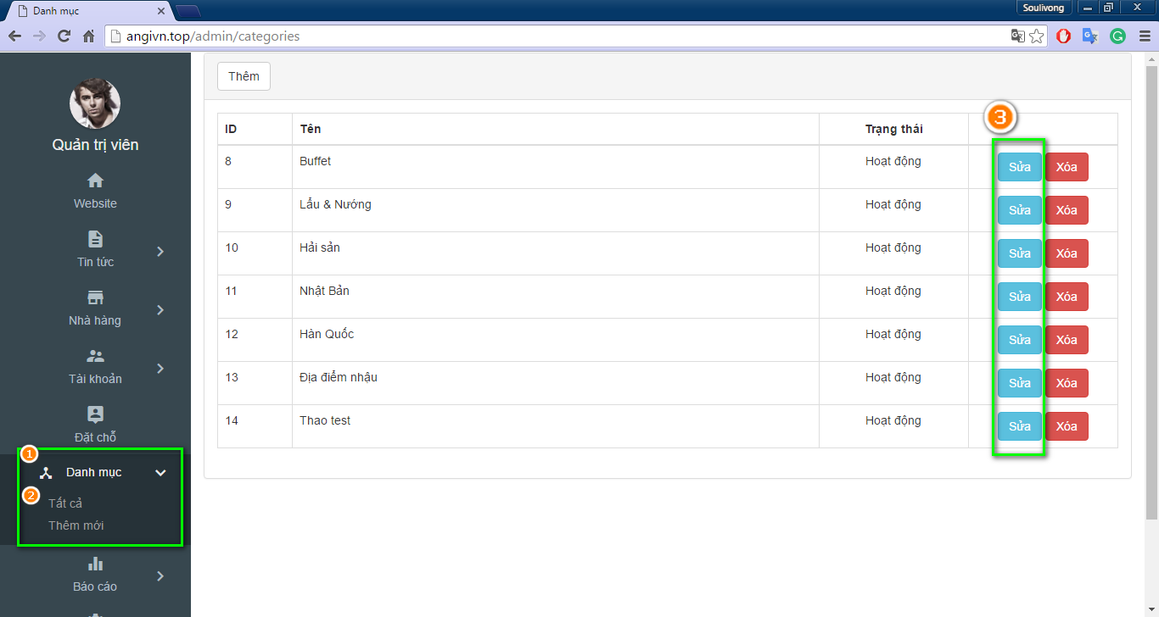

Figure 22: Edit category

* 1. Modify information as needed and click on “Lưu” button

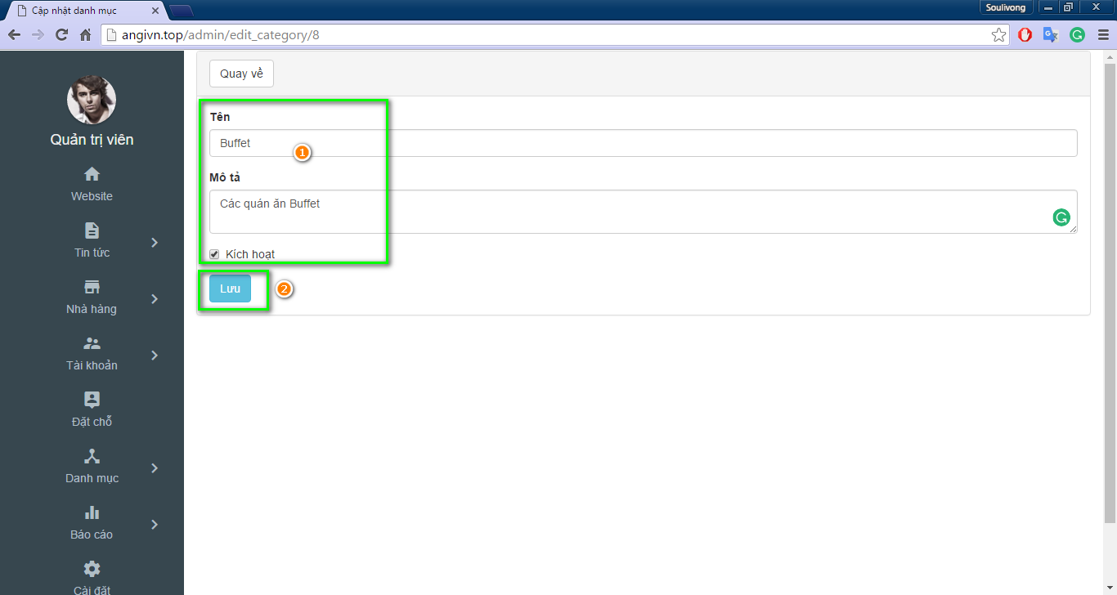

Figure 23: Save change

#### How to activate or deactivate user

* 1. Access admin page then click on “Tài khoàn”, click on “Tất cả” tab

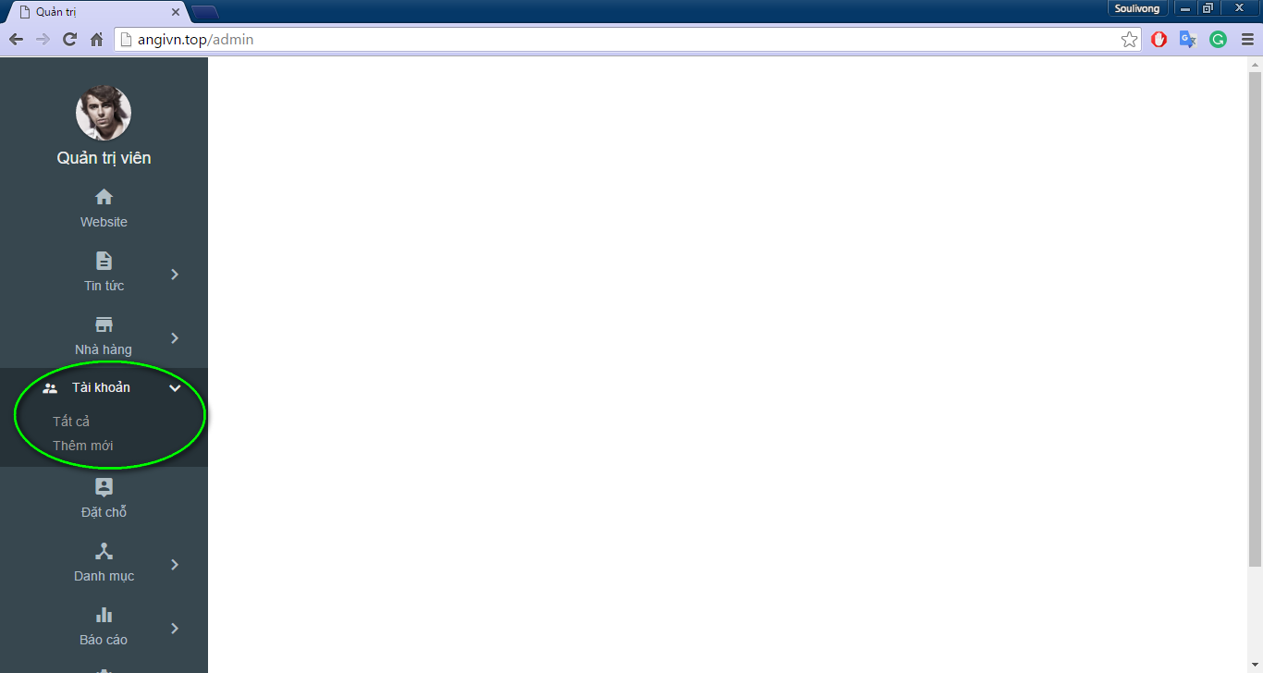

Figure 24 View user

* 1. Choose your desired restaurant and click on “Sửa” button

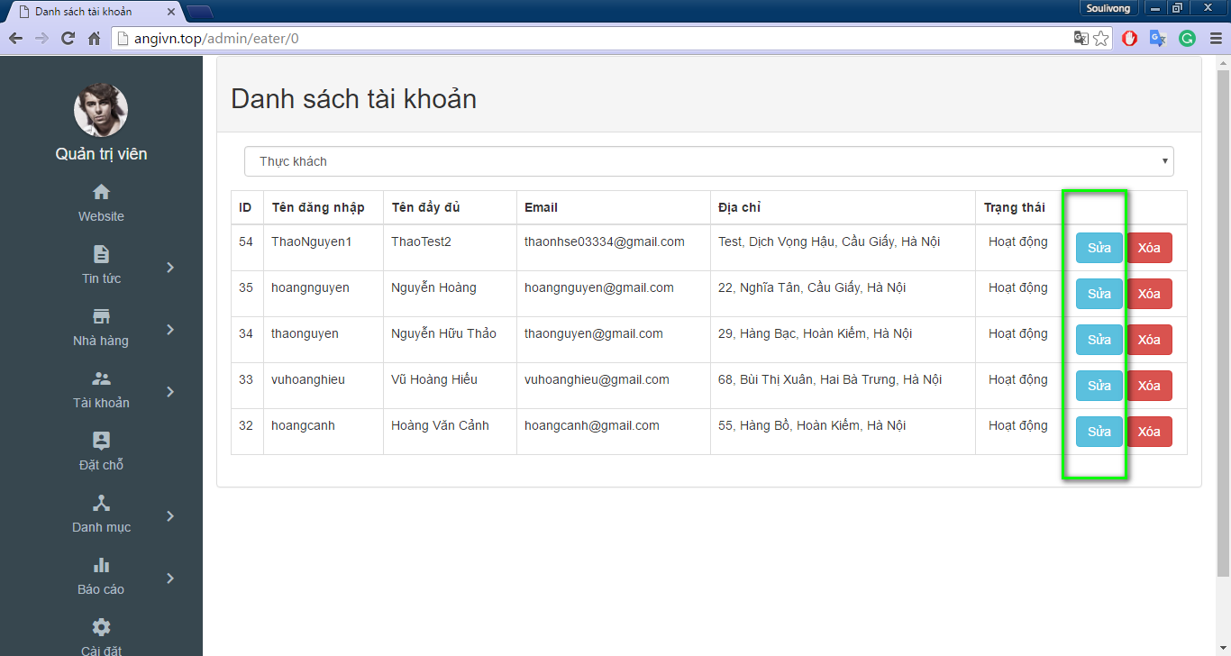

Figure 25: Edit restaurant

* 1. Click on “Duyện” check box to activate or deactivate user

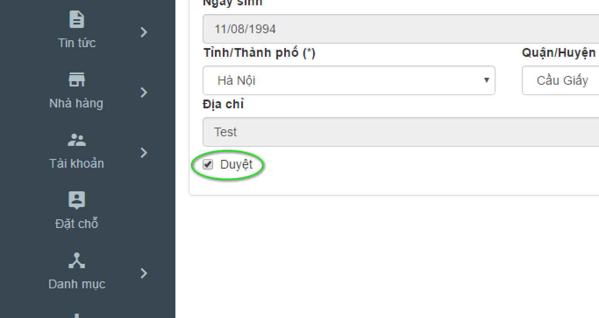

Figure 26: Active user

#### Activate or deactivate restaurant guide

* 1. Access admin page and click on “Tài khoàn” click on “Nhà hàng” tab

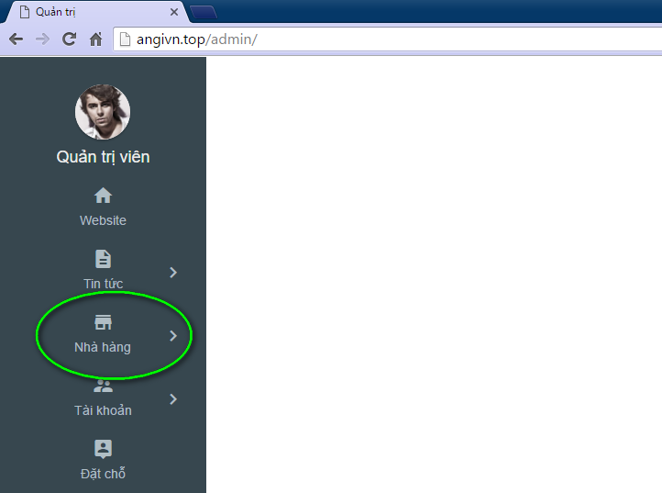

Figure 27: Manage restaurant

* 1. Choose your desired restaurant and click on “Sửa” button

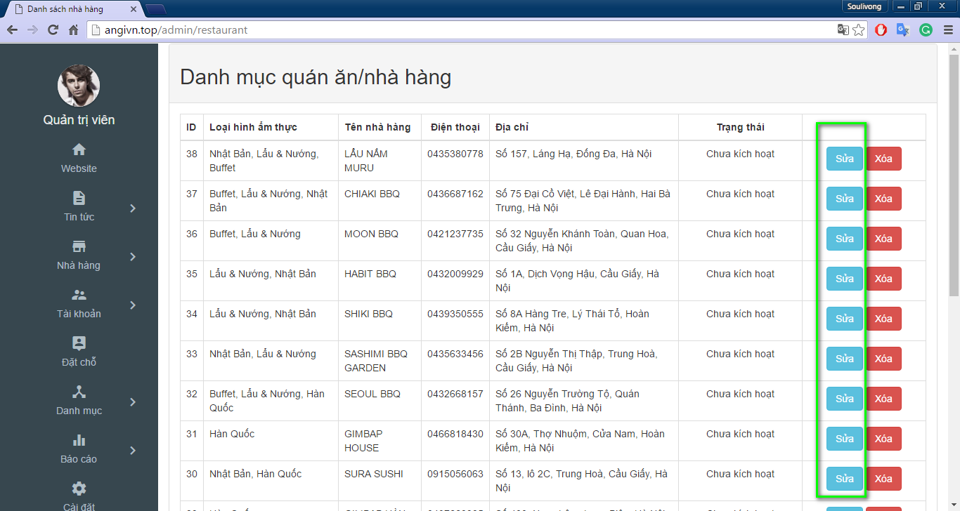

Figure 28: Edit restaurant

* 1. Click on “Kích hoạt” checkbox to activate or deactivate restaurant

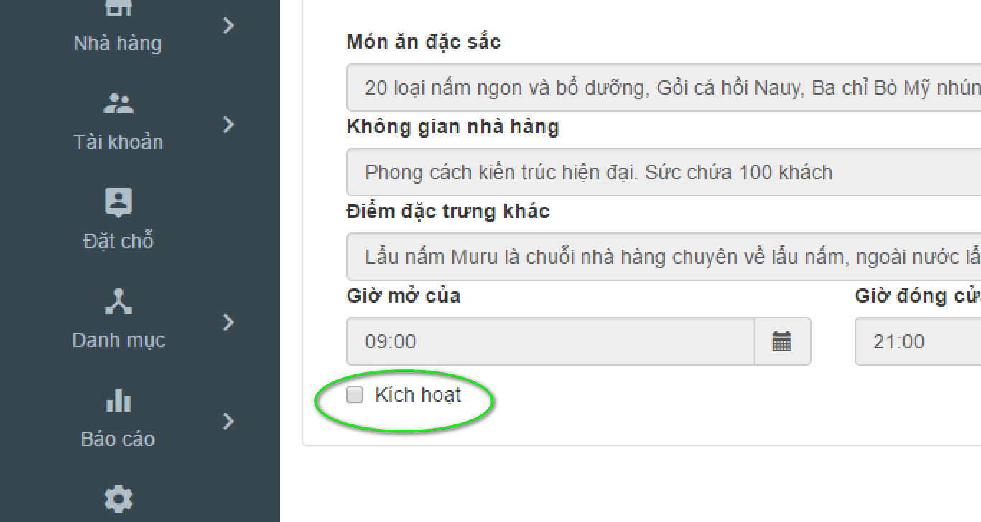

Figure 29: Active restaurant

#### How to rate a restaurant

* + Follow steps similar to UC004 – 07: activate or deactivate restaurant, but instead of clicking on “Kích thoát” checkbox click on “Đánh giá nhà hàng” dropdownlist.

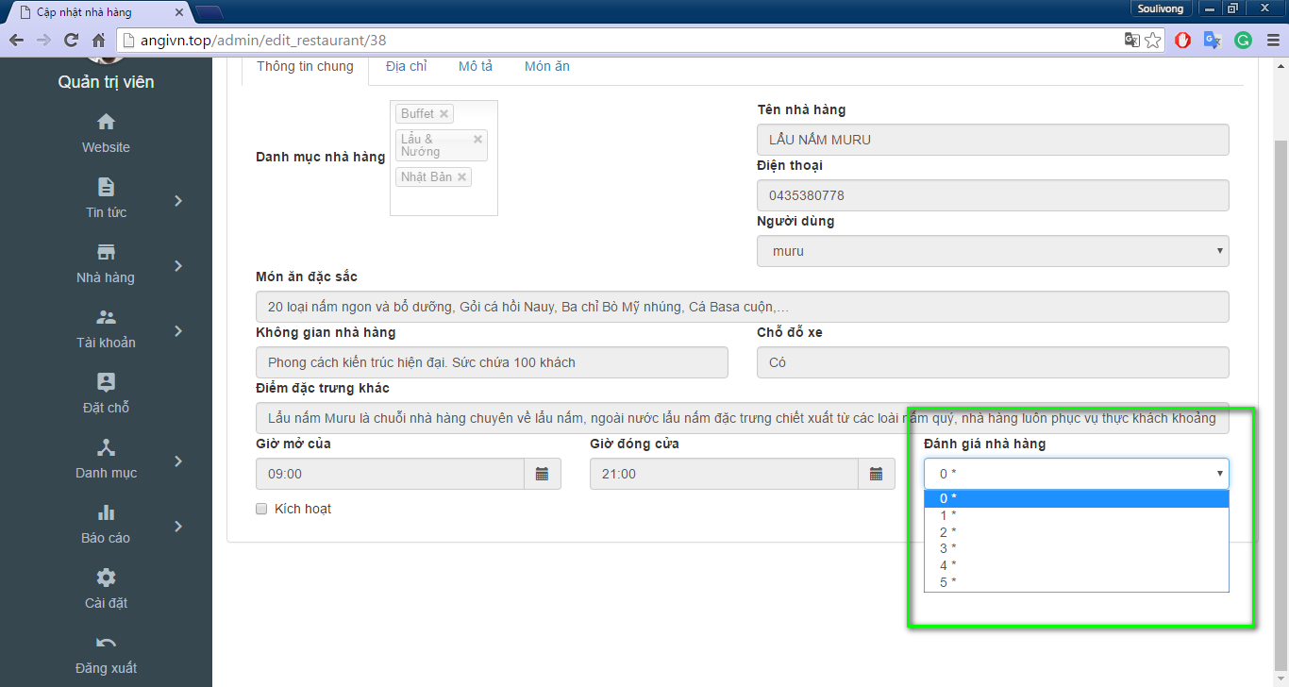

Figure 30: Rate restaurant

#### Delete a restaurant or user

* + Delete restaurant follow steps similar to activate or deactivate restaurant, but instead of clicking on “Sửa” button click on “Xóa” button, then click on “OK” button in the dialog box

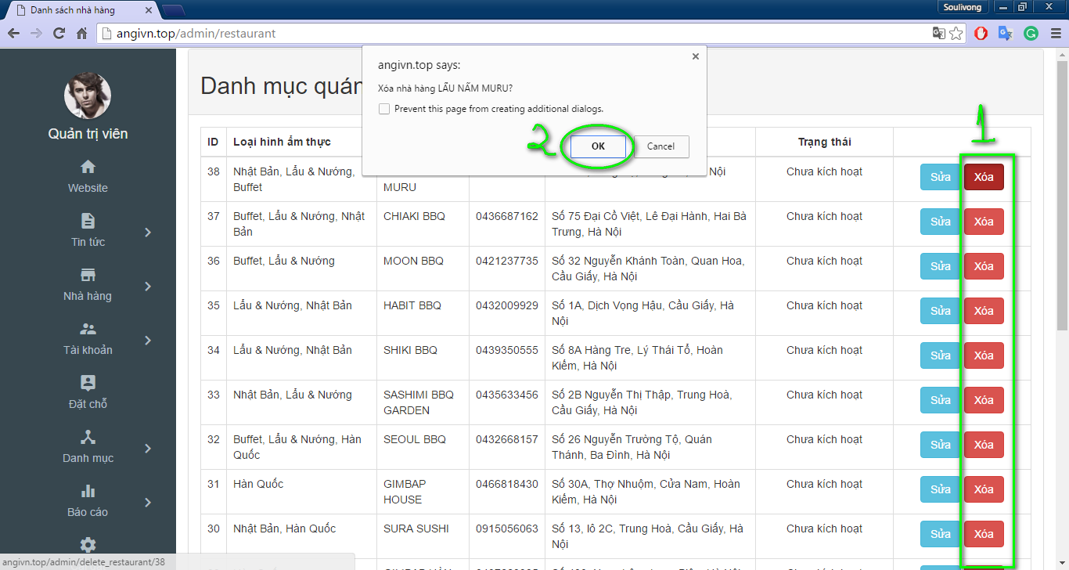

Figure 31: Delete restaurant

* To delete user, change to tab ‘Tài khoản’ and click delete corresponding to user then click ok in dialog to confirm that similar to delete restaurant

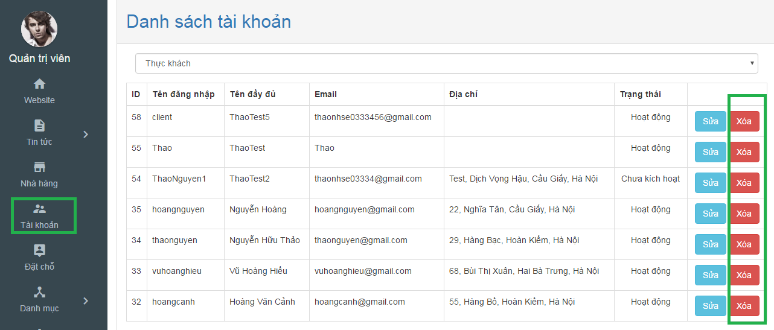

Figure 32: Delete user

#### How to manage all booking in your website

* In admin page move to ‘Đặt chỗ’ tab in left navigation to view list of booking

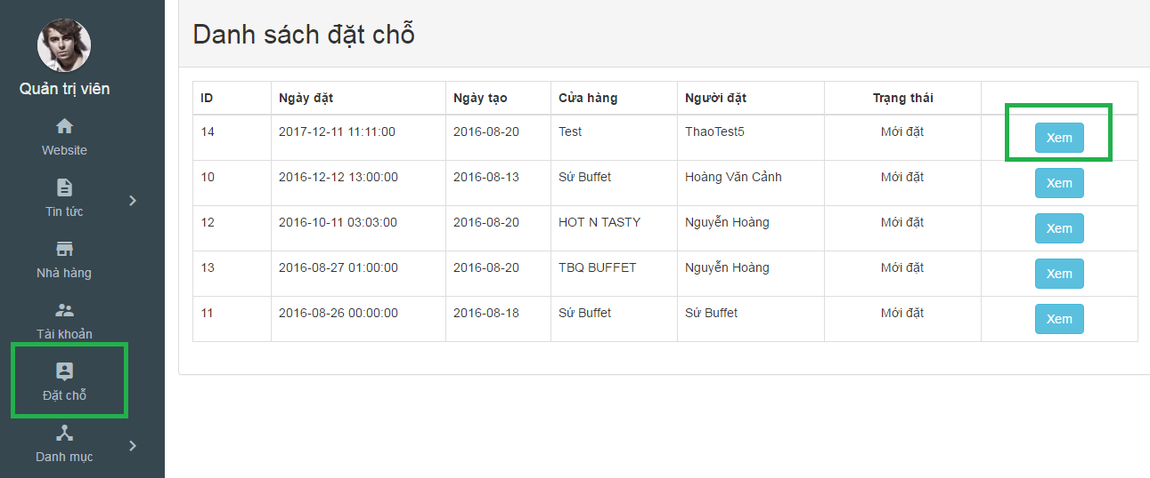

Figure 33: View booking

* Then you can click on ‘xem’ to view more detail about booking

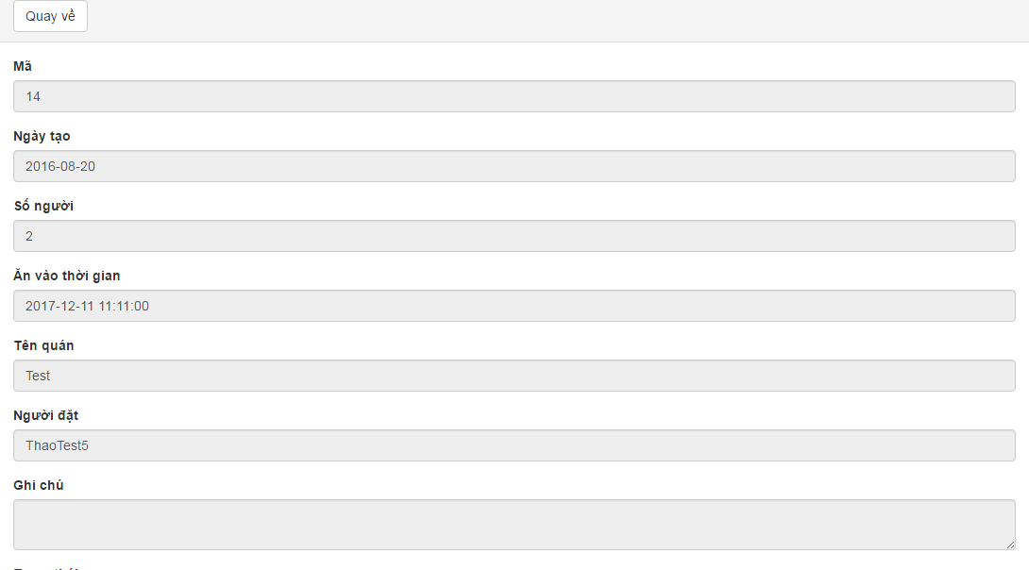

Figure 34: Booking detail

* After that, you can click on ‘Quay ve’ to come back to booking list

#### View website statistic

* In admin page, click on ‘Báo cáo’ tab to view more information

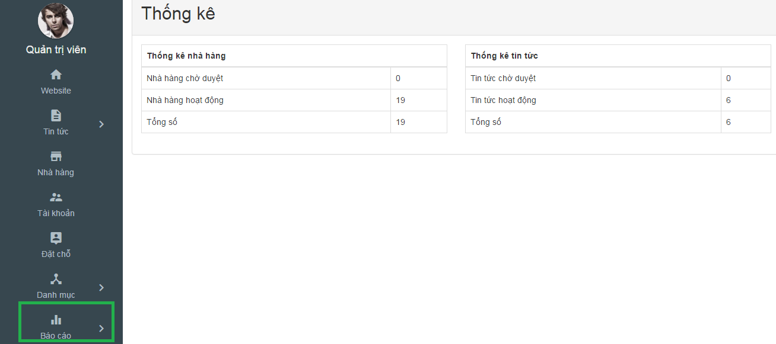

Figure 35: Report

### Guide line for Customer

#### How to login to your account?

1. Hover mouse over “Đăng nhập” text on the top right of the navigation bar

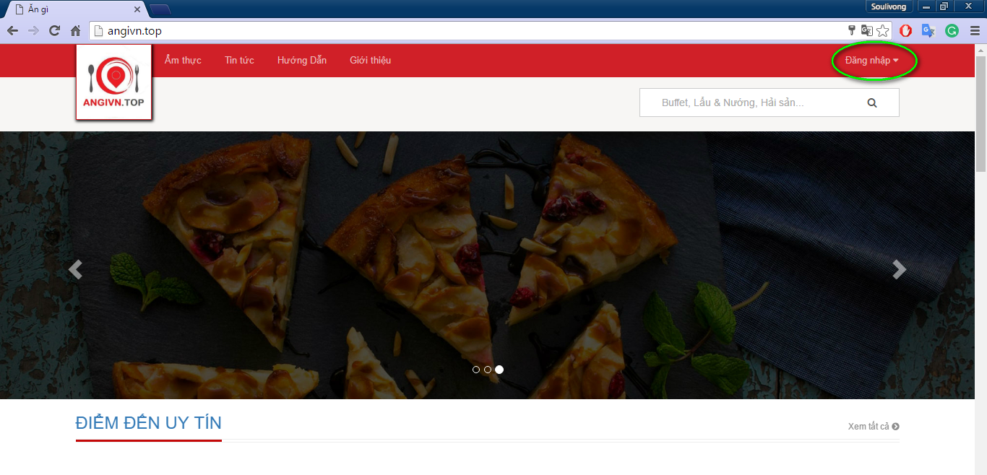

Figure 36: Login location

1. Click on “Đăng nhập button”

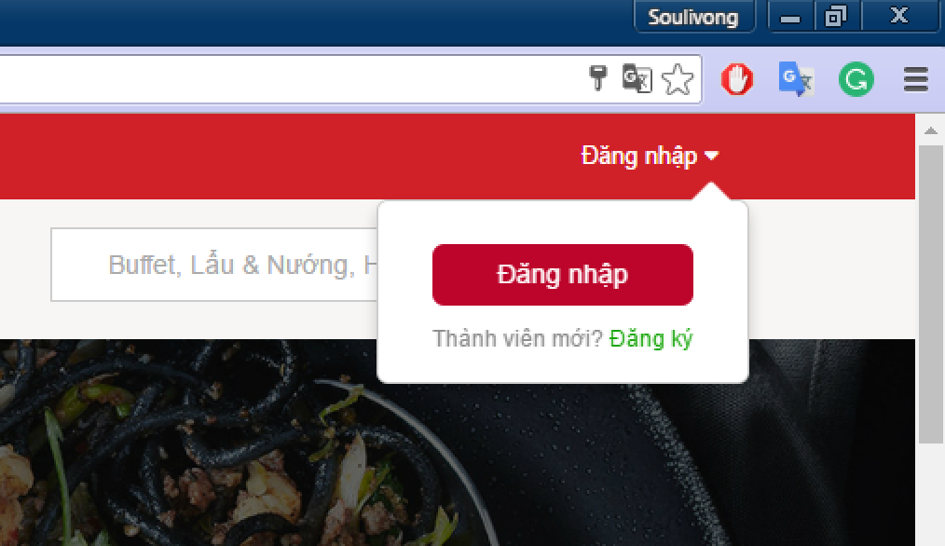

Figure 37: Login button

1. Enter user name or email and password into test boxes and click on “Đăng nhập button”

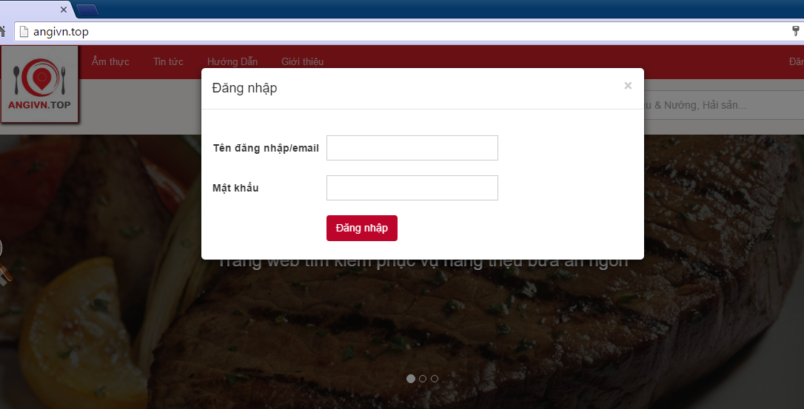

Figure 38: Login form

#### Logout from your account

Method 1**:** Hover mouse over “Xin chào” - your username/email text on the top right of the navigation bar, then click on “Đăng Xuất link”

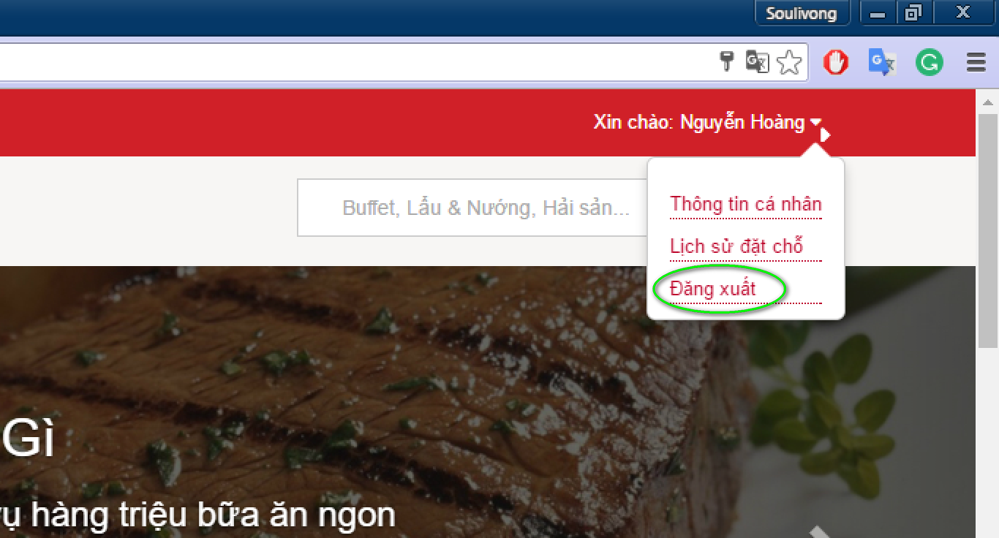

Figure 39: Logout 1

Method **2:**

* Hover mouse over “Xin chào your username/email” text on the top right of the navigation bar, then click on “Thông tin cá nhân” link

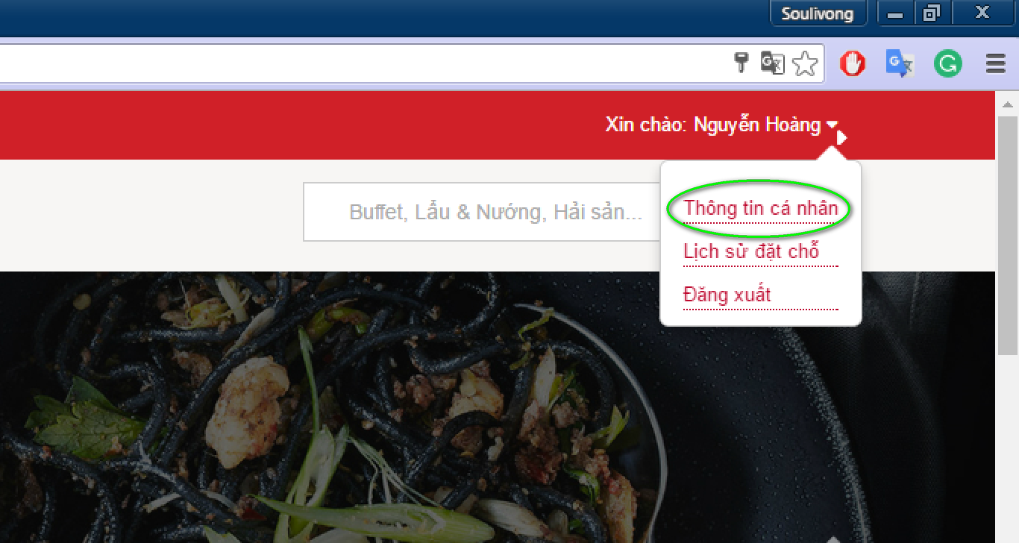

Figure 40: Profile link

* Click on “Thoát” tab

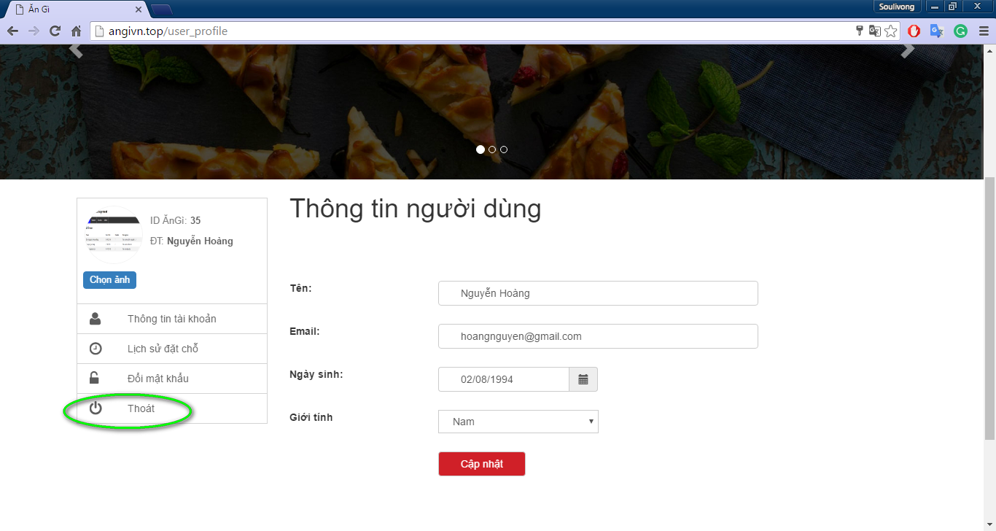

Figure 41: Logout 2

#### View your account/profile

* Logged in as customer by
* Hover mouse over “Xin chào your username/email” text on the top right of the navigation bar, then click on “Thông tin cá nhân” link



Figure 42: Profile link

#### After that, you can update account

* In user’s profile page, customer can edit information and click ‘Cập nhật’ to update account

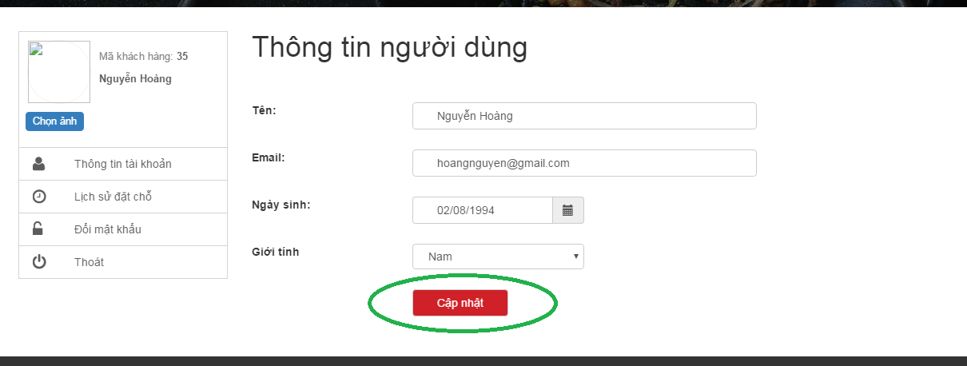

Figure 43: Update profile

#### You can update password by following

1. On profile click on ‘Đổi mật khẩu’.
2. Type old password, new pass word and re-new password that match new pass word
3. Click ‘Cập nhật’.

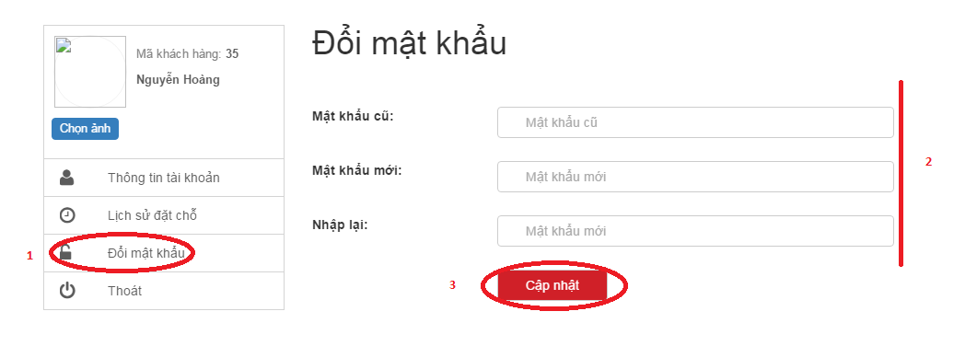

Figure 44: Change password

#### Step by step to book restaurant

* On restaurant detail page, type booking detail (1) on the booking form on the right panel and then click on ‘Đặt chỗ ngay’ .

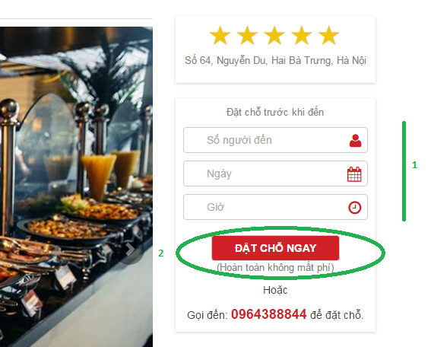

Figure 45: Booking

#### After that, you can view your booking history b

* Method 1: Hover mouse over name text on the top right of the navigation bar and click on ‘Lịch sử đặt chỗ’

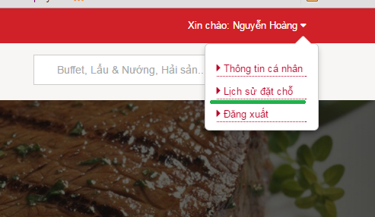

Figure 46: Manage booking

* Method 2: In profile page click on ‘Lịch sử đặt chỗ’ link

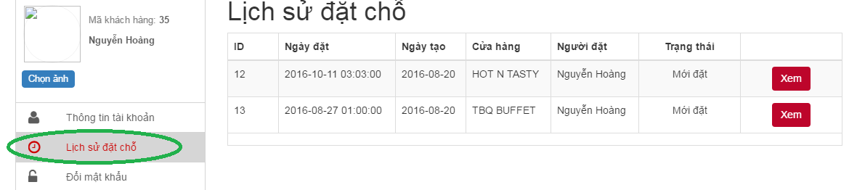

Figure 47: View booking

#### Step by step to upload your picture as avatar

* In user profile click on ‘Chọn ảnh’

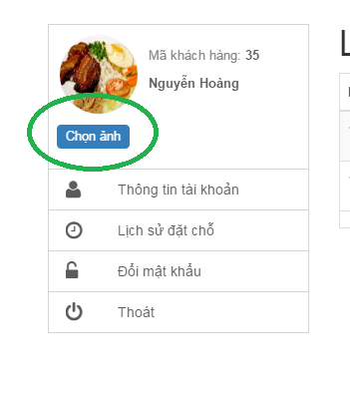

Figure 48: Chose image

* Click Upload to upload a picture then double click on a picture to choose as avatar

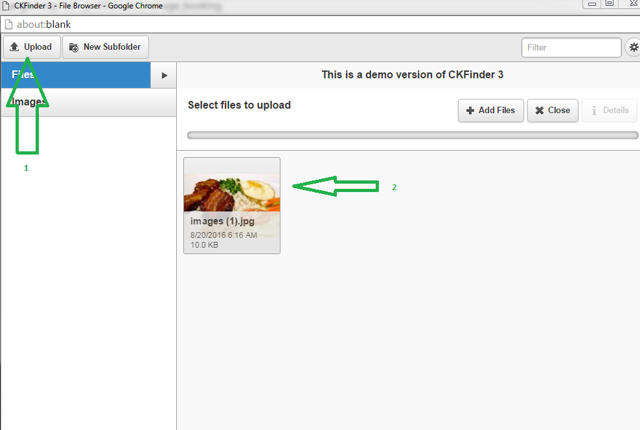

Figure 49: Upload image

* Click ‘Lưu’ to save change

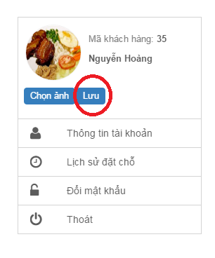

Figure 50: Save change

### Guide line for Restaurant management

#### How to add and update your restaurant

* After login to your restaurant owner account(similar to customer), click on ‘Quản lí nhà hàng’ in the menu

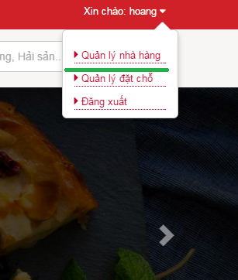

Figure 51: manage restaurant

* In the profile user can see restaurant information, if this is a new restaurant, all field will be blank. Then user can add or modify information. There are 4 tab to put information.

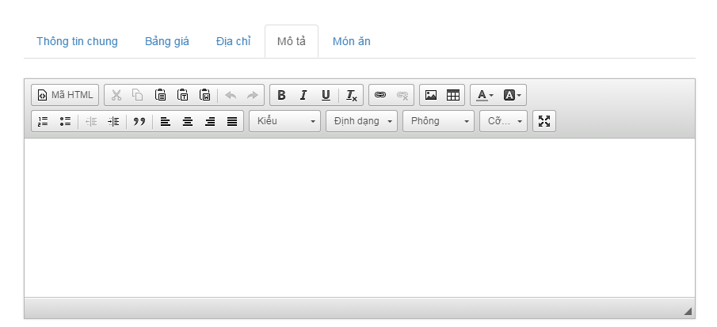

Figure 52: Restaurant description

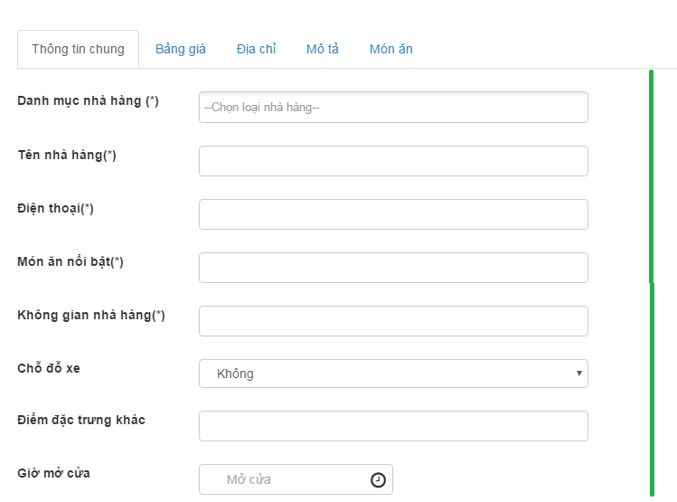

Figure 53: Restaurant info

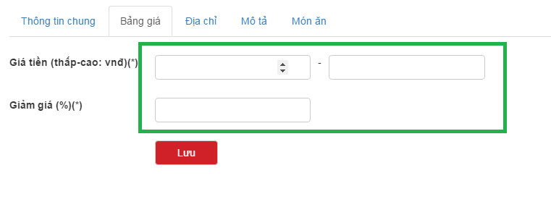

Figure 54: Menu

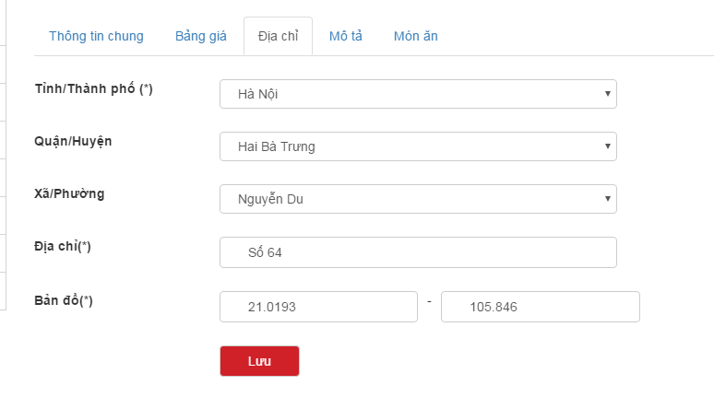

Figure 55: Address

* After type all information to form, user can click ‘lưu’ to save/update all restaurant information in bellows tabs.

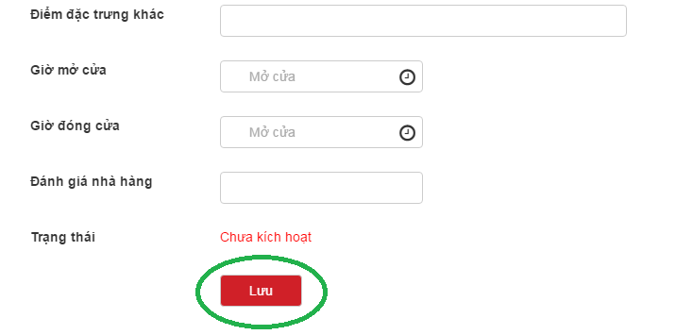

Figure 56: Save change

#### Step by step to add or delete restaurant banner

Note: Restaurant must be activated to add or delete banner, user has maximum 6 banner.

* After go to profile (similar to UC 003\_01). Click on ‘Banner nhà hàng’
* Click on ‘Image’ picture to add and choose an image (similar to up avatar )

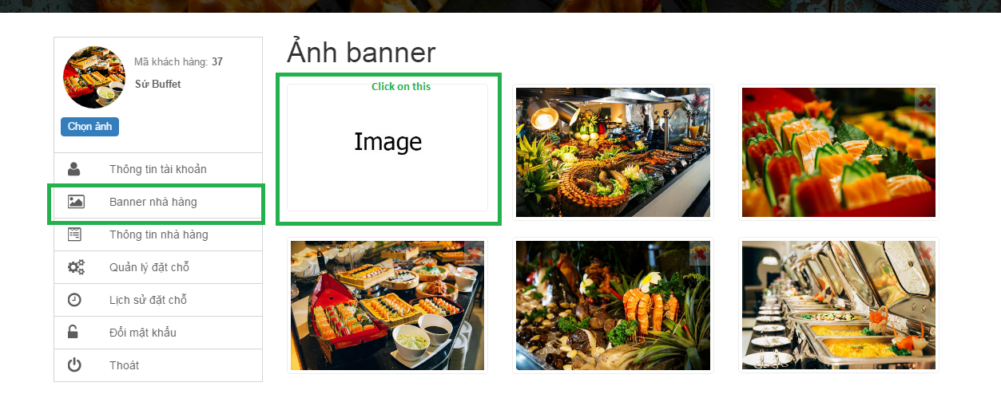

Figure 57: Add banner

* After double click on a picture, it will be add to restaurant banner
* Click on cross mark in the top of a banner to delete it

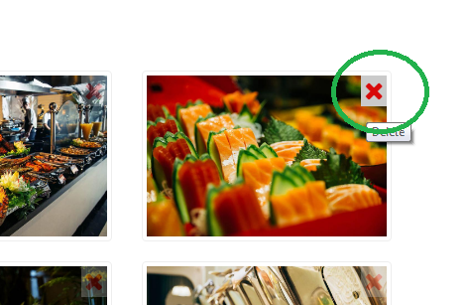

Figure 58: Delete banner

#### Set restaurant profile picture

* Similar to upload avatar in customer case. With owner, avatar is also restaurant profile picture.

#### How to add food to your restaurant

* In restaurant info page, click on tab ‘Món ăn’ then click ‘Thêm món ăn’

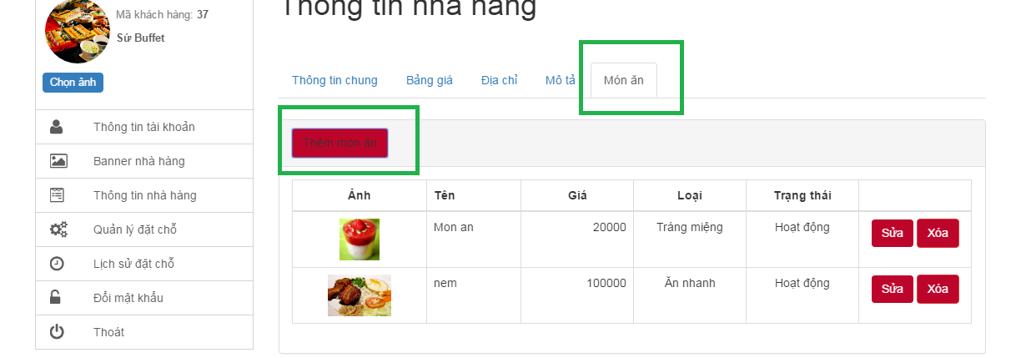

Figure 59: Add food

* An input form will be displayed, then insert food information to form, you can also upload image for food like upload avatar

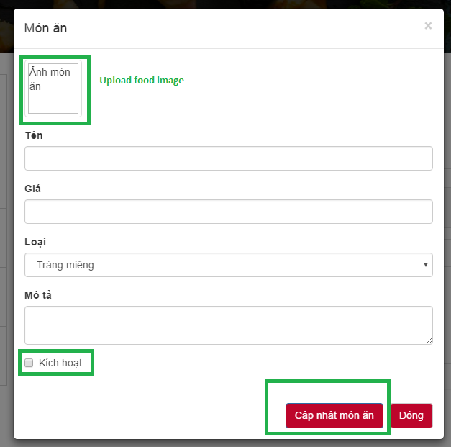

Figure 60: Type food info and save

* Check or uncheck ‘Kích hoạt’ to active/deactivate food
* After all click on ‘Cập nhật món ăn’ to save change

#### View – Update food

* On food panel, click on ‘sửa’ button corresponding to food then a new edit form will be displayed with old information.

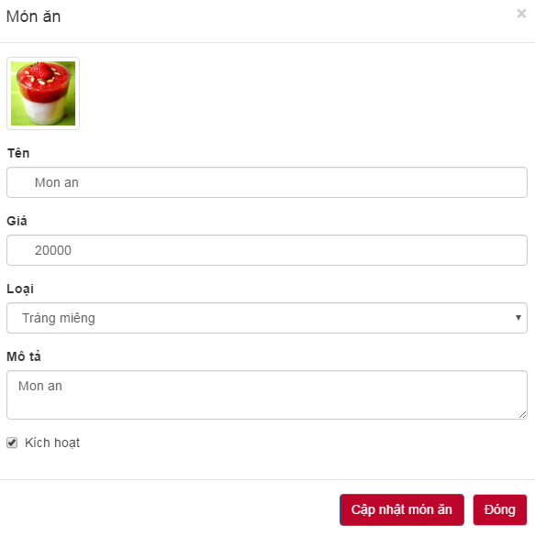

Figure 61: Update food

* Now you can modify info, change avatar and click ‘Cập nhật món ăn’ to save change

#### Delete food

* In food panel, click on delete button next to a food, then a confirm dialog will be display, click ok to remove food from restaurant

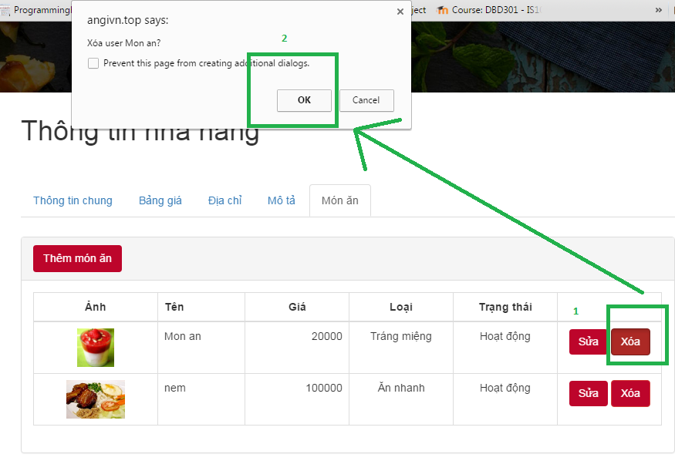

Figure 62: Delete food

#### Guide for manage booking

* On profile, click on ‘Quản lí đặt chỗ’ then click ‘xem’ to view a booking detail

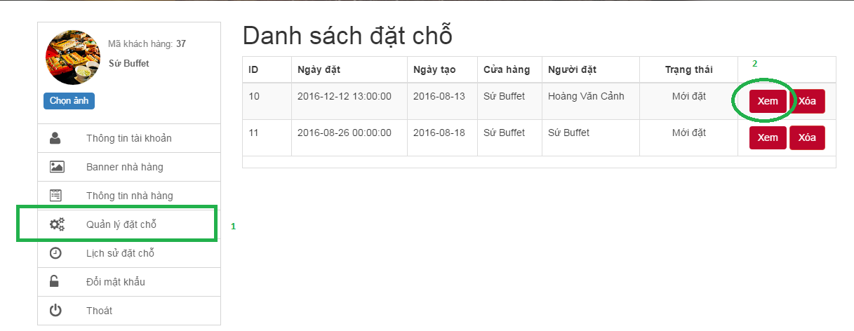

Figure 63: Manage booking

* Change booking status and click ‘Cập nhật trạng thái’ to save change

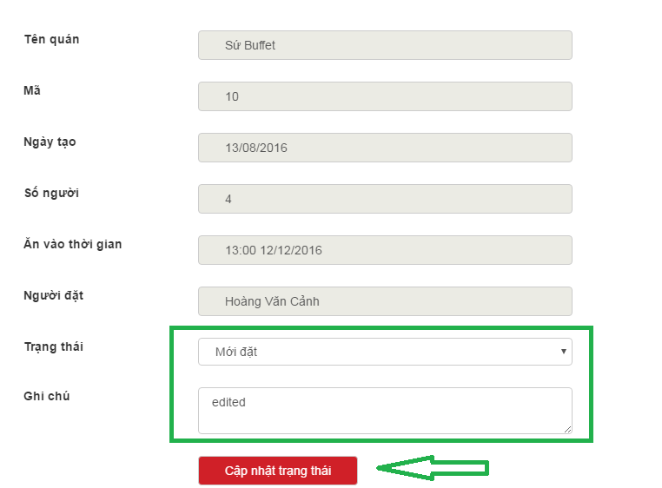

Figure 64: Update booking status

### Guide line for Guest

#### How to access to our website?

* On the browser, type ‘http://angivn.top/’ and press enter then website home page will be displayed on your screen.

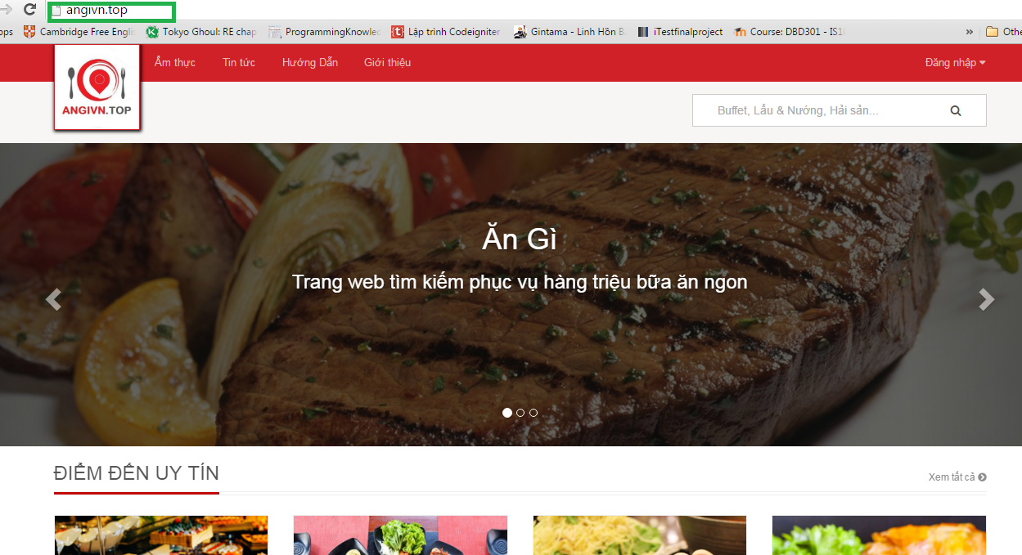

Figure 65: Access to system

* From here you can borrow many restaurants. We also filter some restaurants by top sale, top rate for you to find easier. To view more click ‘Xem tất cả’

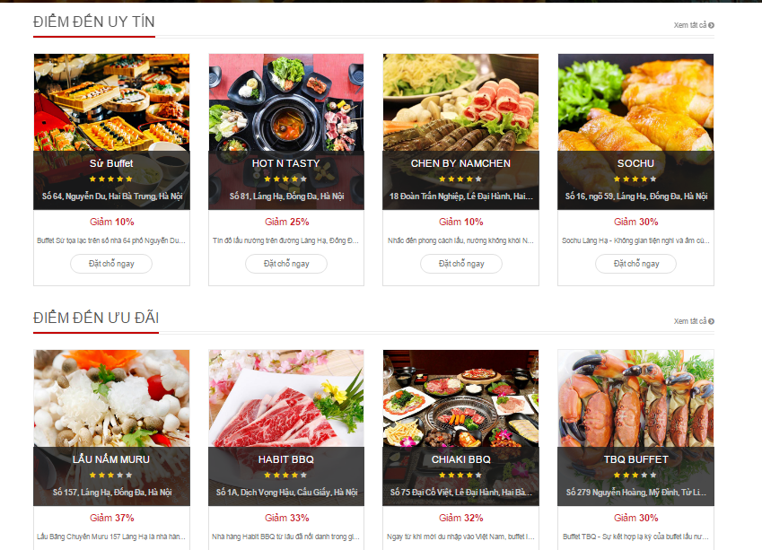

Figure 66: View home content

#### List all restaurant in a category by

* Hover mouse over “Ẩm thực” text on the top menu then chose a category

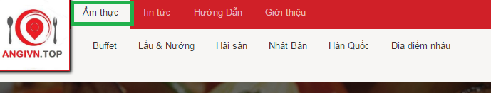

Figure 67: Chose category

* After that website will move to category page as bellow

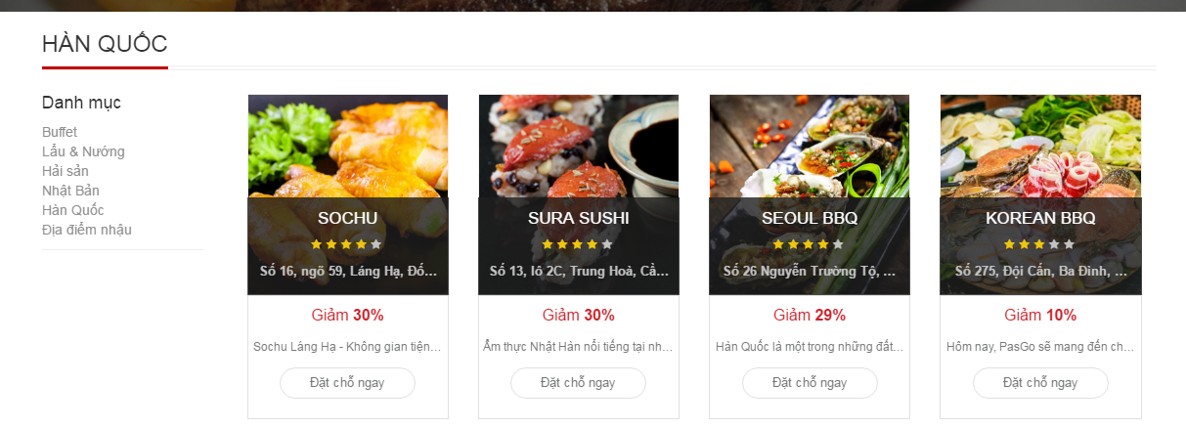

Figure 68: View result

* Then you can filter restaurant by left navigation panel.

#### Find restaurant by using search box and filter result

* Click on search box at the top right of website and type search key word in this

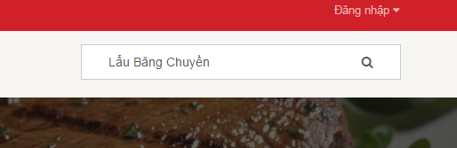

Figure 69: Search box

* Then click on magnifying glass icon to start searching, after that website will display search result page as bellow

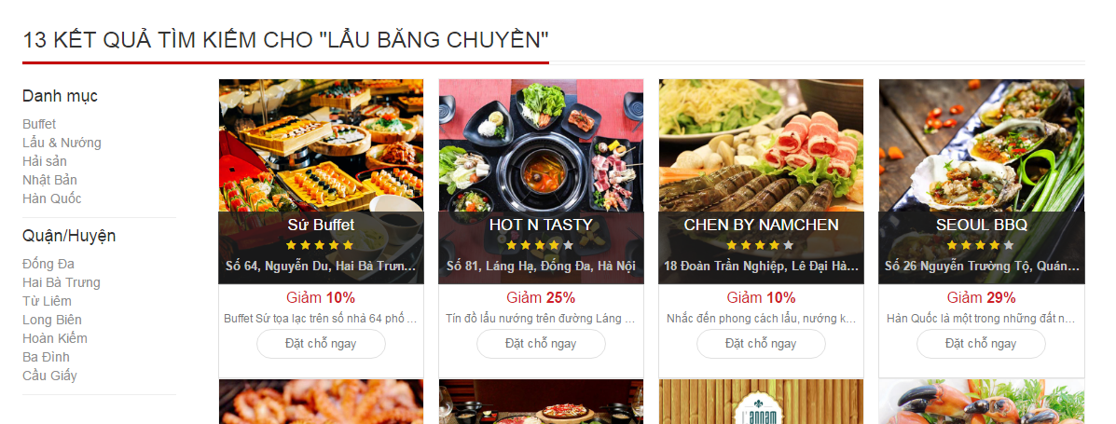

Figure 70: Search result

* After that look at left navigation, by click on this you can filter result base on location or category.

#### How to read restaurant detail page

* To view a restaurant detail, click on restaurant avatar that you see by using search or filter function, then website will move to restaurant page as bellow

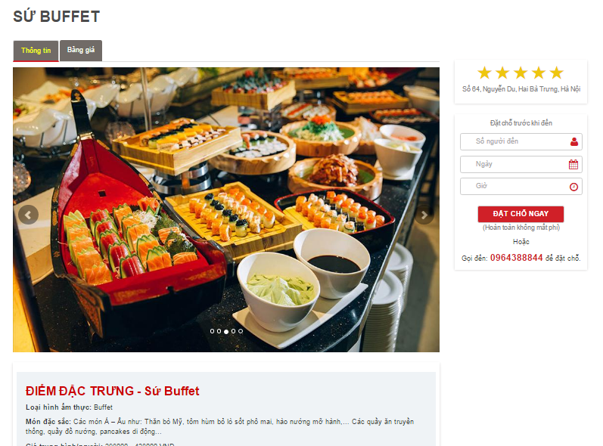

Figure 71: Restaurant detail page

* Click to ‘Bảng giá’ tab to view more about restaurant’s menu

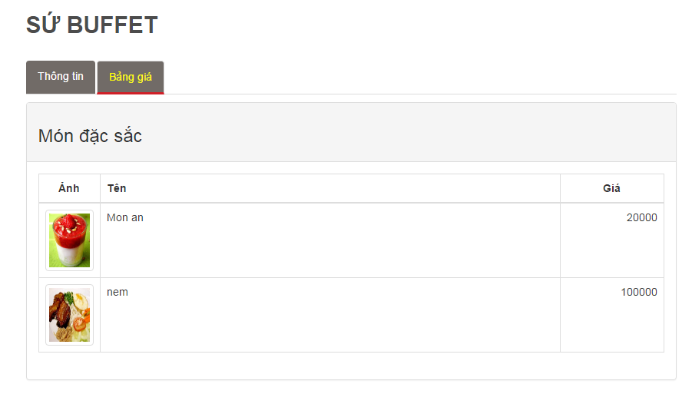

Figure 72: Menu tab

#### Step by step to view website’s new

Method 1: View news by category

* Hover mouse over “Tin tức” text on the top menu then chose a category

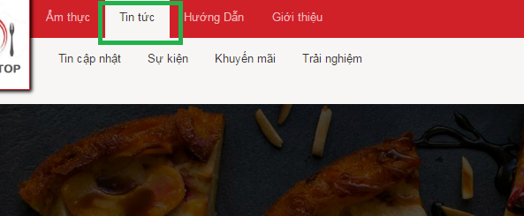

Figure 73: News category

* Click on a category bellow to go to view category page

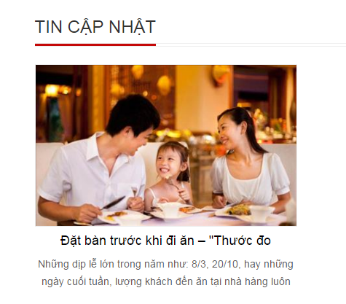

Figure 74: News by category

* Then click on a new to read detail

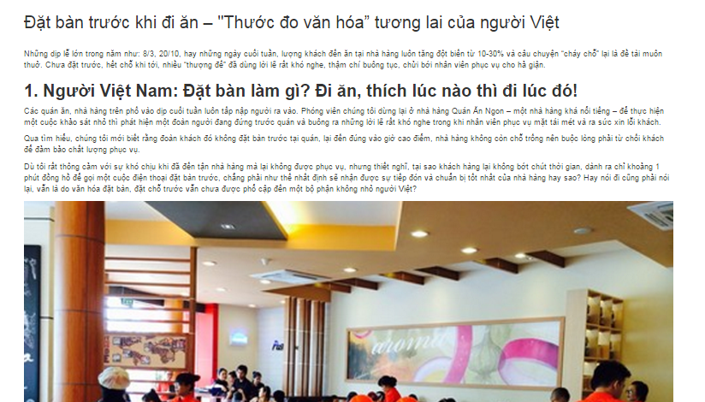

Figure 75: Read new

* Method 2: View newest news by go to the button of home page to view

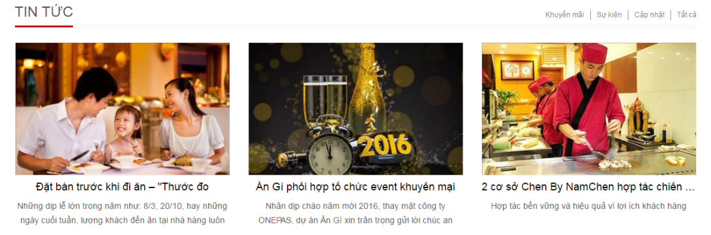

Figure 76: New at footer

#### How to Like, share, comment a restaurant

Note: We use Facebook API for this function so you have to log in to Facebook.

* In restaurant detail page go to button you will see social group here

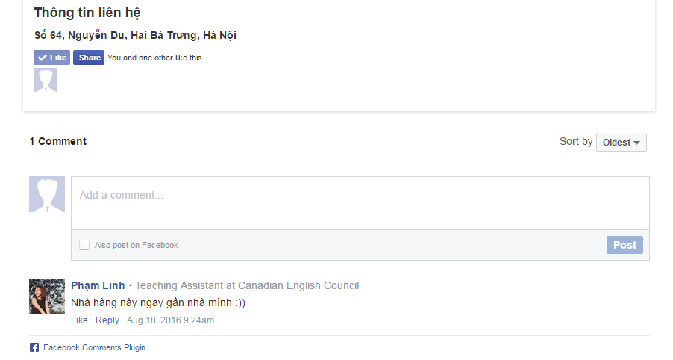

Figure 77: Facebook function

* From here you can like/unlike, share by click on corresponding button
* You can comment to restaurant by Facebook post form
* You can also like, reply another’s comment,… and another Facebook function here.

#### Step by step to register an account

* Hover mouse over “Đăng nhập” text on the top right of the navigation bar, then click on “Đăng ký” link

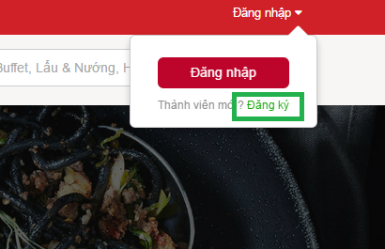

Figure 78: Register link

* Then website will go to register page like bellow

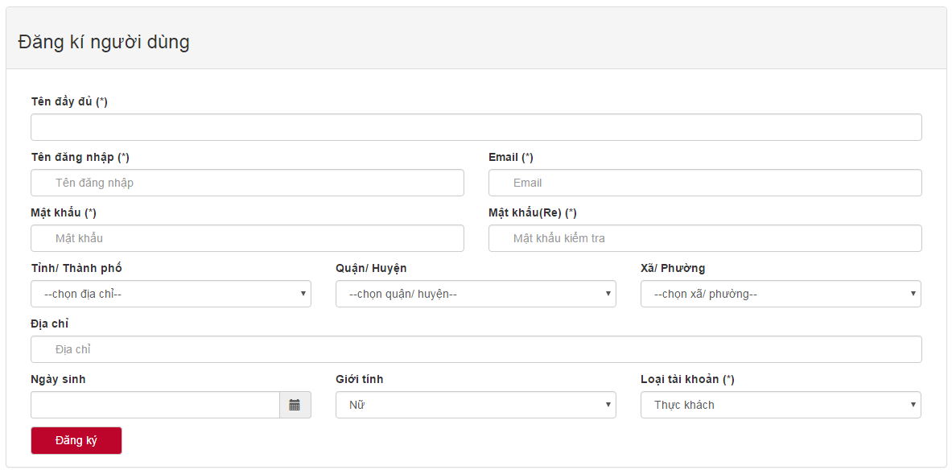

Figure 79: Register form

Note:

\_ (\*) field is required.

\_ Password length is at least 6 characters.

\_ Email must following format xxxx@xxx.xxx.

\_ Password must match re-Password

# PROJECT RESULT REPORT

## Product Judging

### Advantages of AGC web application

AGC system is developed based on the understanding of internet and computing devices. Both of them are used everywhere and in every field in life which have made our day to day tasks become easier and simpler. Therefore, AGC system provides users functionalities to access information anytime and anywhere.

1. **Admin**

* Admin is a website site owner which he/she/they can gain profit generated by AGC system.
* Able to control users’ account and check the system status.

1. **Customers**
   * Check menu in restaurants.
   * Check restaurants’ addresses.
   * Check which restaurants has top rating.
   * Check which restaurants has the highest discount.
   * Make an online table booking.
   * View others restaurants’ information in detail.
   * View restaurants’ list based on interest, address, restaurant category, etc.
   * Have a quick search for any interested information.
   * Interact with social network.
2. **Restaurant owners**

* Help restaurant owners to have more channel to communicate their products or services to their potential customers.
* Manage table booking online.
* Check business status by viewing statistical data in the system.
* Restaurant owner account can be used as customer account which he/she can perform all functionalities those customer is able to.

1. **Guests**

* View all restaurants’ information.
* View all general information in AGC system.

### Current limitations of AGC web application

* Functions for restaurant owners cover only basic functions.
* Users cannot directly rate restaurants and give reviews.
* Like and Comment functionalities still rely on social network.
* Images management still rely on third party web server.
* Customers cannot have a live chat with restaurant owners.
* No live notification service for users.
* Numbers of registered restaurants cover only Hanoi, Vietnam.
* Some graphical user interfaces do not provide understandable look and feel to users enough.
* Language used is only Vietnamese.

### Expectation in the future

* Develop more functionalities for restaurant management.
* Manage images purely in AGC system without using third party server.
* Develop live chat functionality between Customers and restaurant owners.
* Develop live notification service for users.
* Expands area of registered restaurants while maintain original areas.
* Develop functionality for users to be able to swap between English and Vietnamese languages.

## Project Summary

|  |  |  |  |
| --- | --- | --- | --- |
| **Project title** | | AGC | |
| **Project advisor** | | Mr Nguyen Van Sang | |
| **committers: 5** | | | |
| 1 | Project manager | Soulivong Phimmathong | [soulivongse03451@fpt.edu.vn](mailto:soulivongse03451@fpt.edu.vn) |
| 2 | Requirement analysis leader | Nguyen Huu Thao | thaonhse03334@fpt.edu.vn |
| 3 | Software design leader | Vu Hoang Hieu | hieuvhse03030@fpt.edu.vn |
| 4 | Development leader | Hoang Van Canh | canhhvse03271@fpt.edu.vn |
| 5 | Quality assurance leader | Nguyen Hoang | hoangnse03193@fpt.edu.vn |
| **Main objective** | | develop a web application that connect customers to restaurant owners | |
| **Purpose** | | provides a convenient way for users to access restaurants’ information | |
| **Items** | | **Plan** | **Actual** |
| Release date | | 24 August 2016 | 24 August 2016 |
| Release version | | 1.0 | 1.0 |
| Days | |  | 144 |
| Weeks | |  | 20 weeks and 4 days |
| Months | | 4 | 4 months and 22 days |
| Test cases + checklists | |  | 191 |
| Documentation pages | |  | 257 |
| Lines of code | |  | Approximately 12470 |

Table 1: AGC project summary

## Lessons Learnt

### Project management skill

* **Work schedule:** we know how to create a plan for daily, weekly and even monthly to ensure the project will reach its goal. All steps of working processes are preliminary planned, and then assigned tasks to members which are given deadlines.
* **Time management:** Even though, we have created a clear schedule. But coding and documenting processes took longer time than they supposed to be. Therefore, in the last phase of development we had a very frequent meeting, working hard all day, and a little more at night in order to bring the work on schedule.
* **Human management:** from this project we have learnt that team work is the most important component in software development and in all others working field. We have more understanding of each member habit, his/her strengths and weaknesses. With this we can ensure that everyone will get the right work load that is suitable to his/her abilities, and he/she will engage to the tasks with satisfaction.
* **Integration management:** We know how to put many complex components in software system together and successfully deploy AGC system.

### Soft skill

* **Communication Skill:** we have known what tools to be used and when to be used in order to communicate effectively.
* **Team work:** before join AGC project we do not know each other before, but suddenly we are grouped together. During 4 months working together, spent a lot of time together, helping each other to solve problems. Most of the time we have conflicts with each other, but those things could be passed because we understand each other and have the same goal which is to accomplish the project successfully.

### Technical skill

* Documentation: a lot of technical documents were created, we have learnt how to write software documentations and used a lot of tools in software documenting.
* Programming languages: Php CodeIgniter framework, MySQL, HTML, CSS, bootstrap, JavaScript, Juery, etc.
* We know to publish website on the internet using host and domain
* Have more understanding of software architecture
* Have more understanding of software testing
* Know how to use Github and Tortoise Git.